Add Item to an Install Kit
To add an item to Install Manager you’ll need to know five things:
- Part Numbers
- Description
- Cost & Quantity
- Extra Labor & Risk
- Display Location
Note: The price associated with install items is added to the equipment price.

1. Part Numbers – back-office view
To add an item to an existing category, you can use specific OEM and Distributor part numbers as shown in Figure 1.
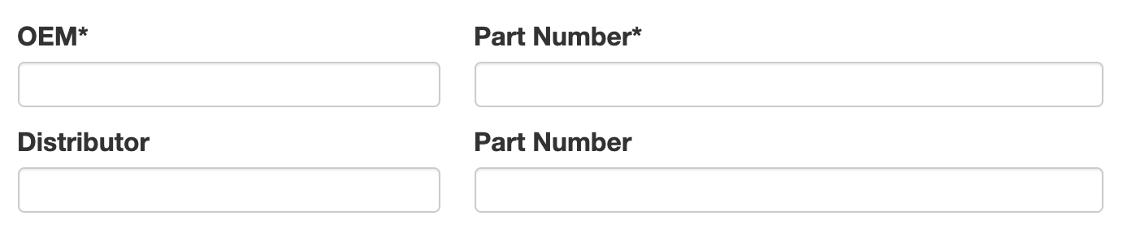
Figure 1 Add Item - Part Numbers. Note the * indicates a required field.
You may also use generic, universal, or company part numbers as shown in Figure 2
.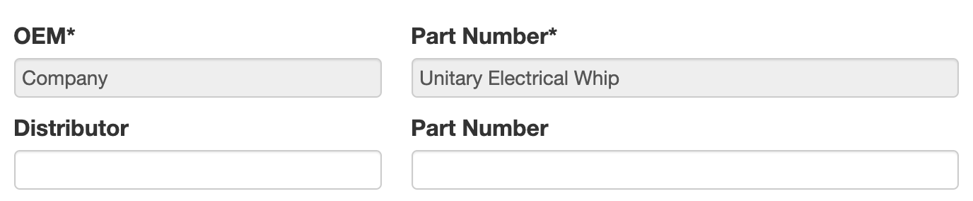
Figure 2 Use of company part numbers.

2. Description
On the app, what you show to the Comfort Consultant (the Shown to Company field of Figure 3) should be easy to recognize. You can show something else to the Customer (the Shown to Customer field) or leave the field blank to hide the item on the proposal. The checkbox makes these two fields identical. You may also (optionally) enter a Description for Admins - think of this as a Yellow Post-It-Note.
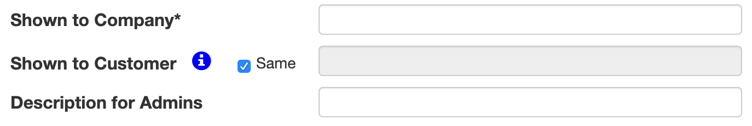
Figure 3 Describing install items.

3. Cost & Quantity
Items default to “1 each” but you can enter the unit cost and the number of items and the software will do the math for you. (Figure 4)
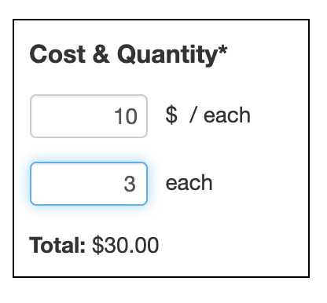
Figure 4 Cost and Quantity
Note: The cost is converted to a price using your Business Rule for pricing the equipment type.
Example: The $30.00 item in Figure 4, with a 50% margin adds $60.00 to the price of the equipment.

4. Extra Labor & Risk
Since each Equipment Type usually has Standard Labor hours, you’ll only enter Extra Labor to install materials when it is over or above your standard. Extra labor hours are added to the standard labor. The cost for this labor is added to the item cost using the labor rate in your pricing rules.
Note: You need a Business Rule for labor in $/Hour to price extra labor.
Example: If your labor rate is $100/Hour and your margin is 50% an extra 1 hour of labor prices out to $200.

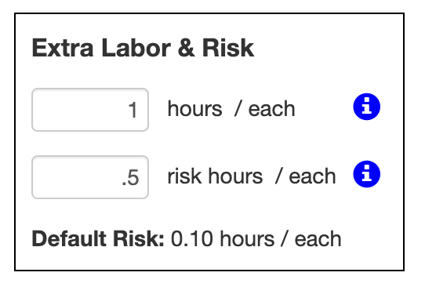
Figure 5 Extra Labor & Risk.

5. Display Location
If shown to the customer, show as a material or accessory.
The default location is in the Materials section of the customer proposal.
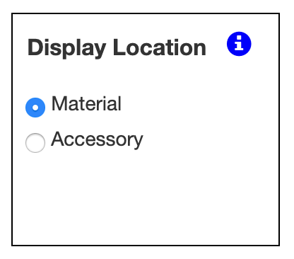
Figure 6 Display Location.

